Lab 2
Sheet1:
Click on “Orders” and then “Sheet1”.
• We want to see sales done based on category.
• Create a worksheet as follows:
• Sheet1:
• Pick up “Sales” and drop it in “Columns”.
• Pick up “Category” and drop it in “Rows”
• Each category contains various sub-category, hence a hierarchy can be made from category and sub-category.
• Sheet 1(Cntd)
• Pick up “Sub-Category” and drop it in front of “Category”.
• Then, the amounts of sale for each furniture can be extracted.
Q1: Provide a snapshot of sheet1.

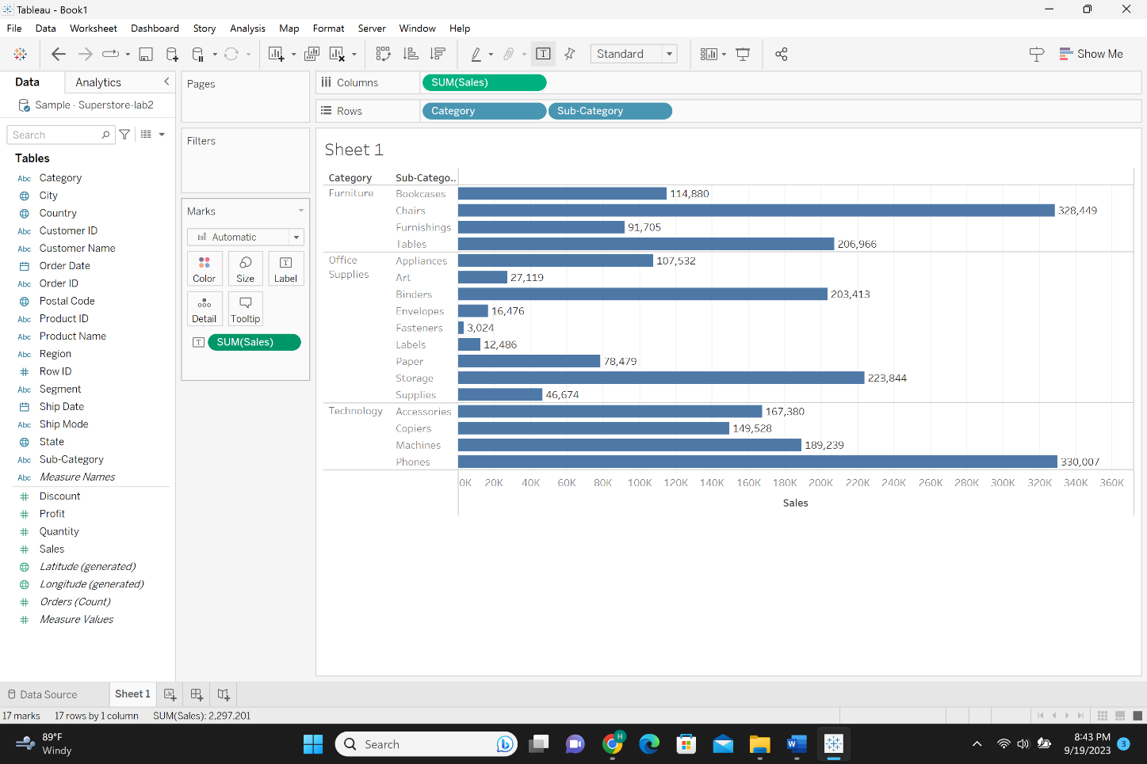
Q2: How much is the “Sales” of “Paper”?
The total sales of paper is 78,479.
Q3: Which “Sub-Category” in “Technology” sold the most?
Using the graph above, the sub-category in technology that sold the most is the phones subcategory with the total phones sales is 330,007.
Q4: Which “Sub-Category” in “Office Supplies” sold the least?
Using the graph above, the sub-category in office supplies that sold the least is the fasteners subcategory with the total phones sales is 3,024.

• I want to have category and sub-category within a hierarchy. So, I have to place it where it belongs
to.
Sheet2:
• Drag “Sub-Category” and drop it under “Category”, which shows a plus sign.
• Then a box pops up and asks you to assign a name.
• Name it “Products”, then a minus sign pops up near the “Category” in the “Rows”, because it has been already expanded.
• Afterwards, the created hierarchy can be drilled down to the lowest level.
• By clicking on minus, you get plus sign and see “Sales” done in “Category” wise. If you click on plus sign, you see “Sales” done by “Sub-Category” wise.
Q5: Provide a snapshot of sheet2.
• You can still remove category and throw it outside and see sales based on “Sub-Category”.
• The more you keep on creating categories, the more you can drill down.
• If we want to add another field to the “Products” hierarchy

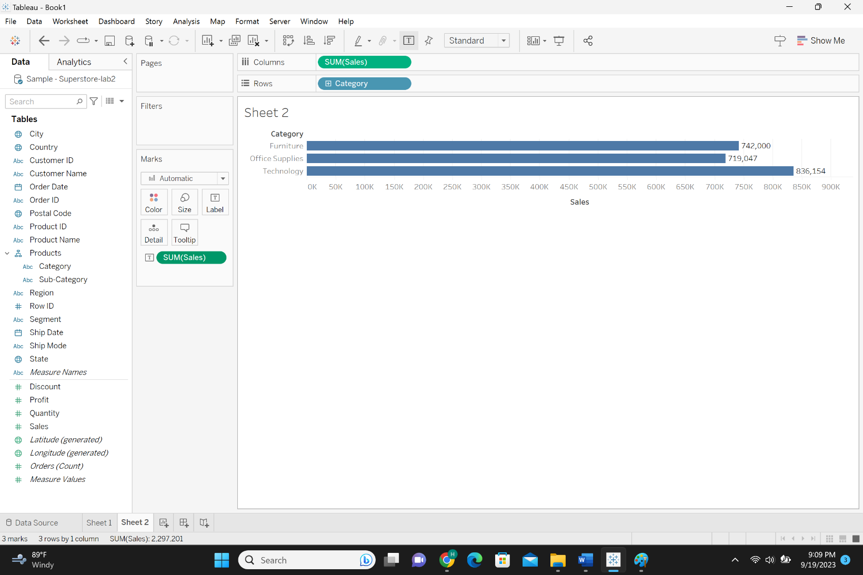
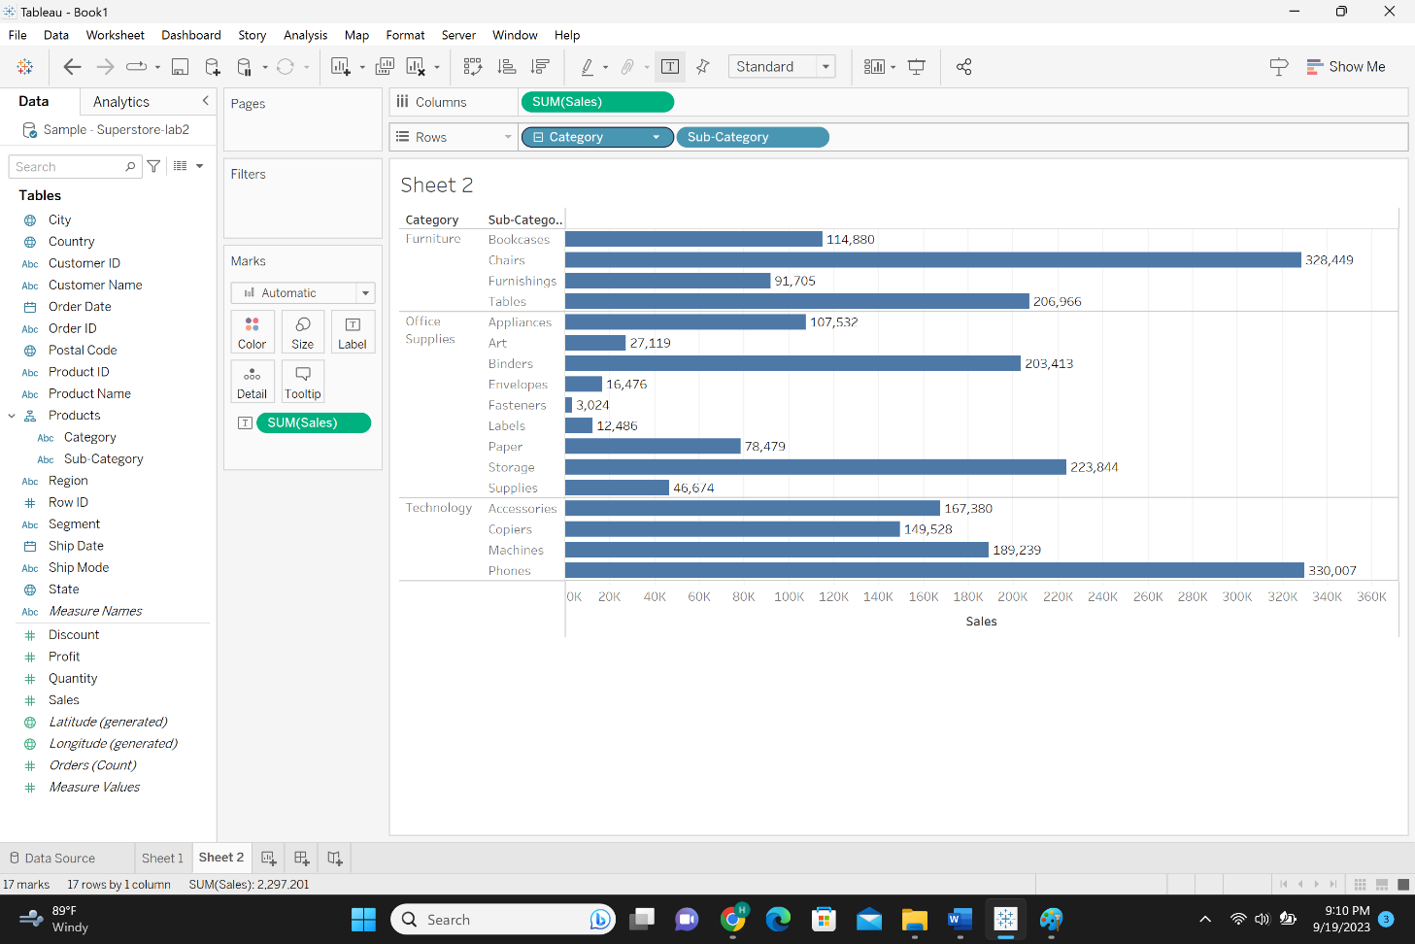
Sheet3:
• Drag and drop “Product Name” under “Sub-Category”
• If you expand the plus sign next to “Sub-Category” you can see the “Product Name”
• You can throw away “Sub-Category” and see the “Product Name”
Q6: Provide a snapshot of sheet3.
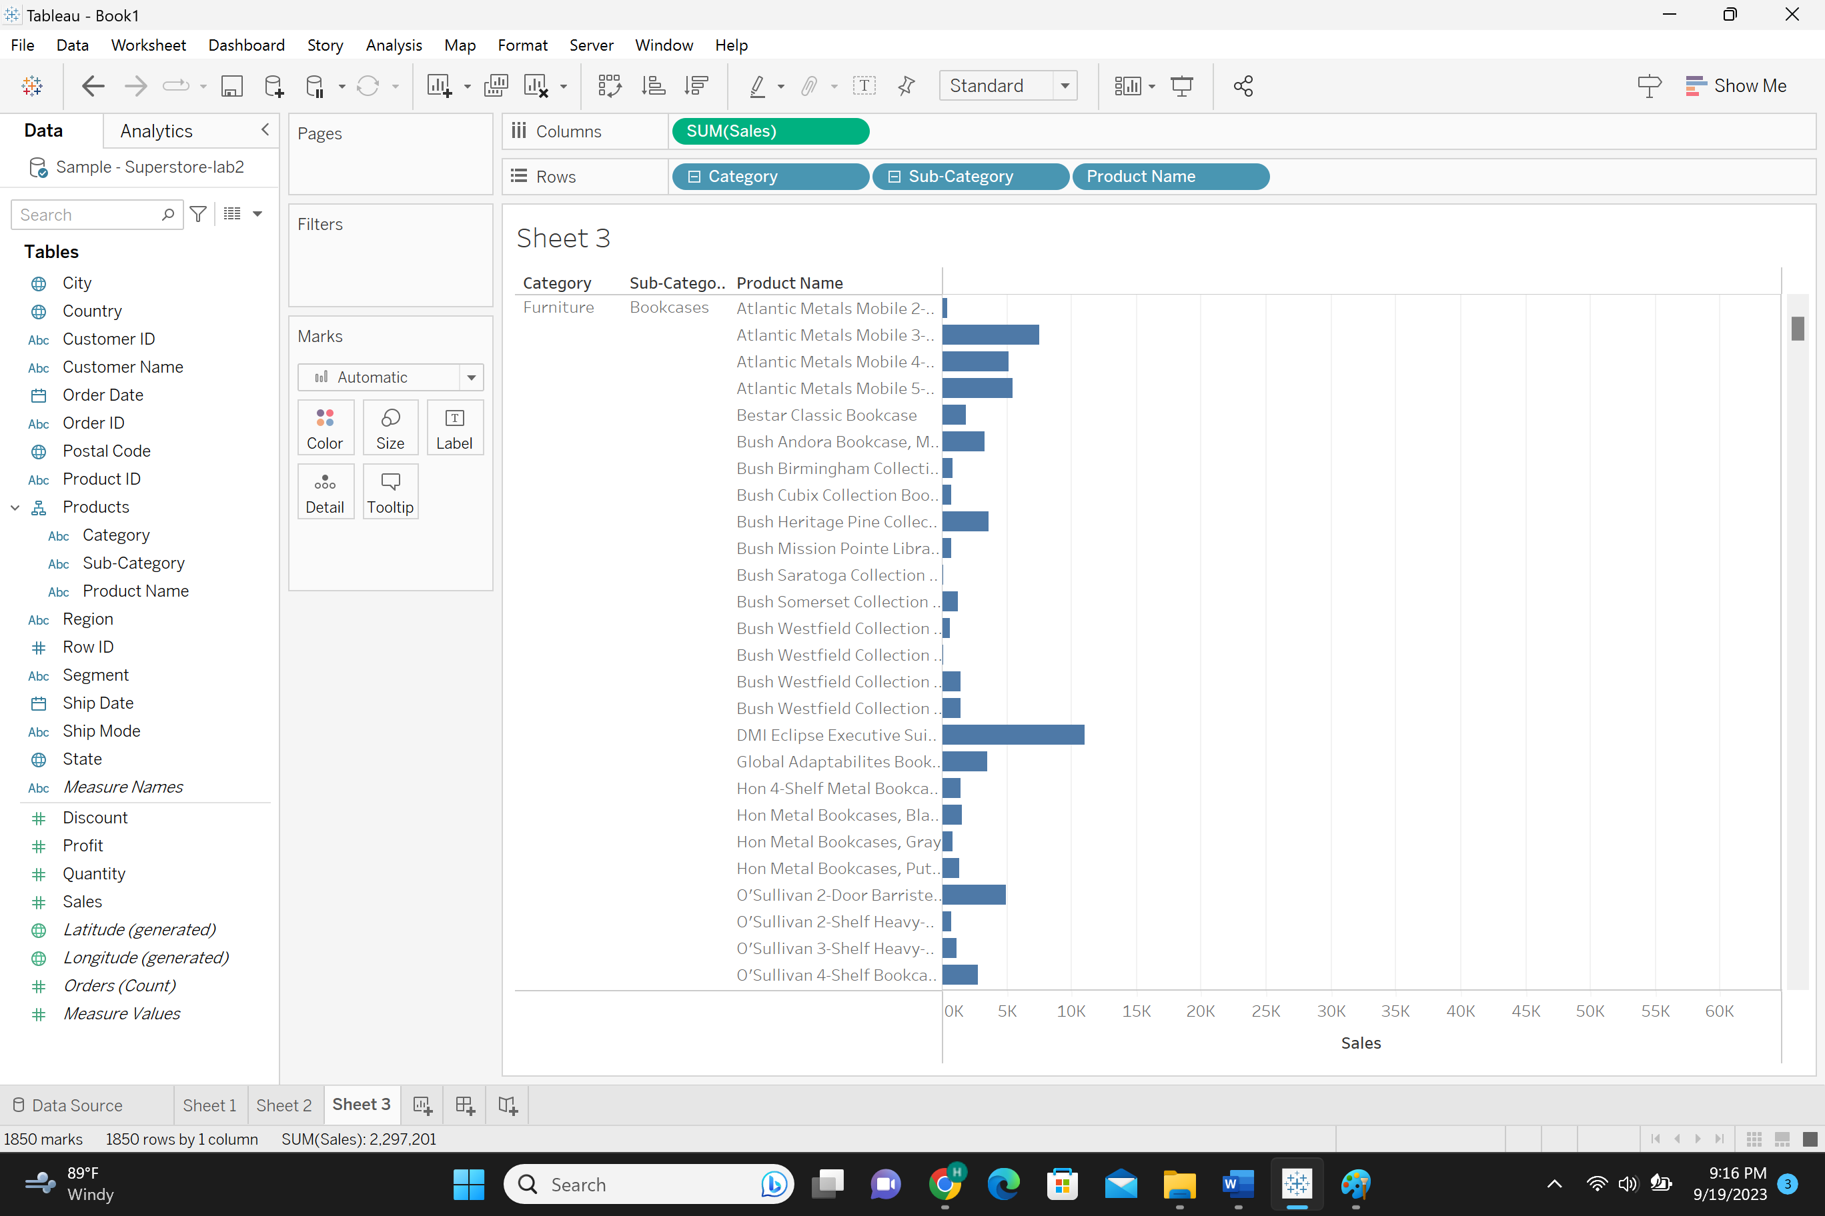
Examine the created hierarchy
• Now you can throw away “Category”, “Sub-Category”, and “Product Name” from “Rows” and drag and drop
“Products” hierarchy.
• By expanding the plus sign, you can see “Category”, “Sub-Category” and “Product Name” pop up.
Change the order of fields within a hierarchy
Sheet4:
• You can move the “Product Name” from its place and put it bellow the “Product”. Then, the order of the hierarchy will be
changed.
• There are some categories which are auto defined such as date categories.
• We want to create a chart showing the amount of sales per date.
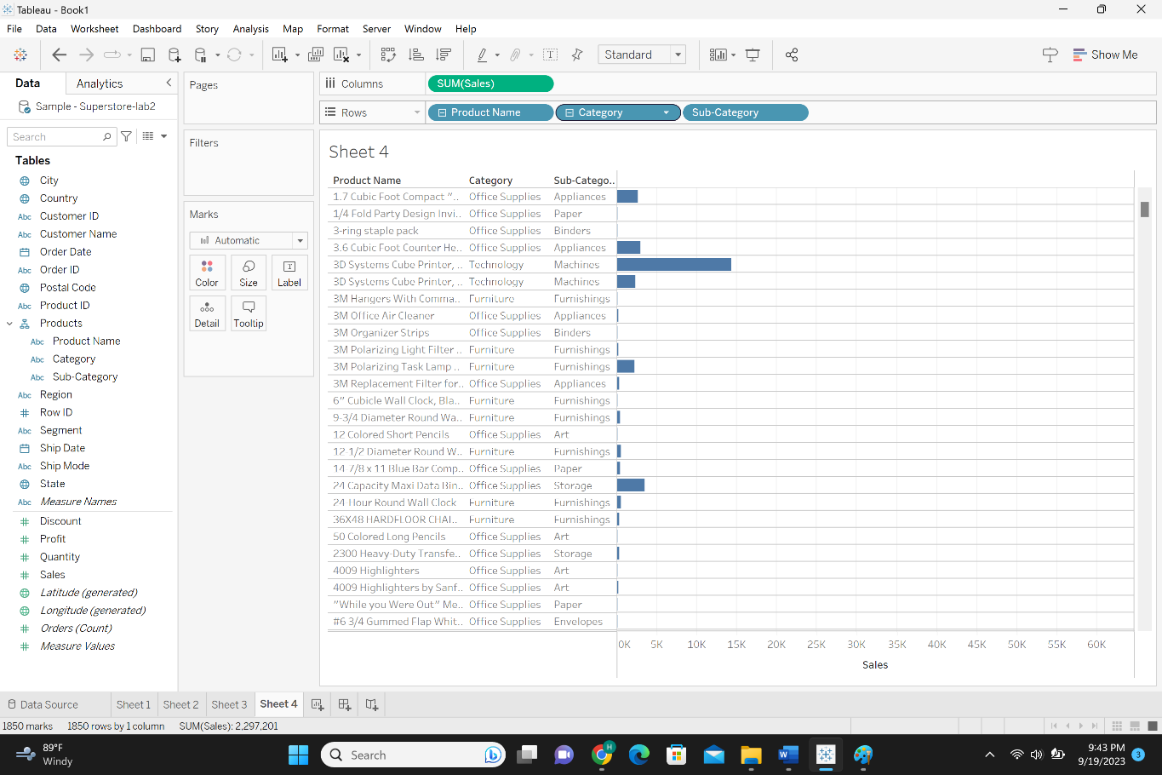
• Sheet4:
• Drag and drop “Order Date(YEAR)” in “Columns” and “Sales” in “Rows”.
• To see “Sales” done based on the times line; days, quarters and years, expand the year field by clicking on the plus sign. Now you see
the sales in each year per quarters.
• Drill down more by expanding the other plus signs.
Q7: Provide a snapshot of sheet4.
• So, if you are a manager of a company and want to see day-wise sales and month-wise sales, you can expand
the hierarchy to month and day using drilling down.
• The date was auto-defined since “Quarter”, “Month”, and “Day” fields did not exist. They are discrete fields.
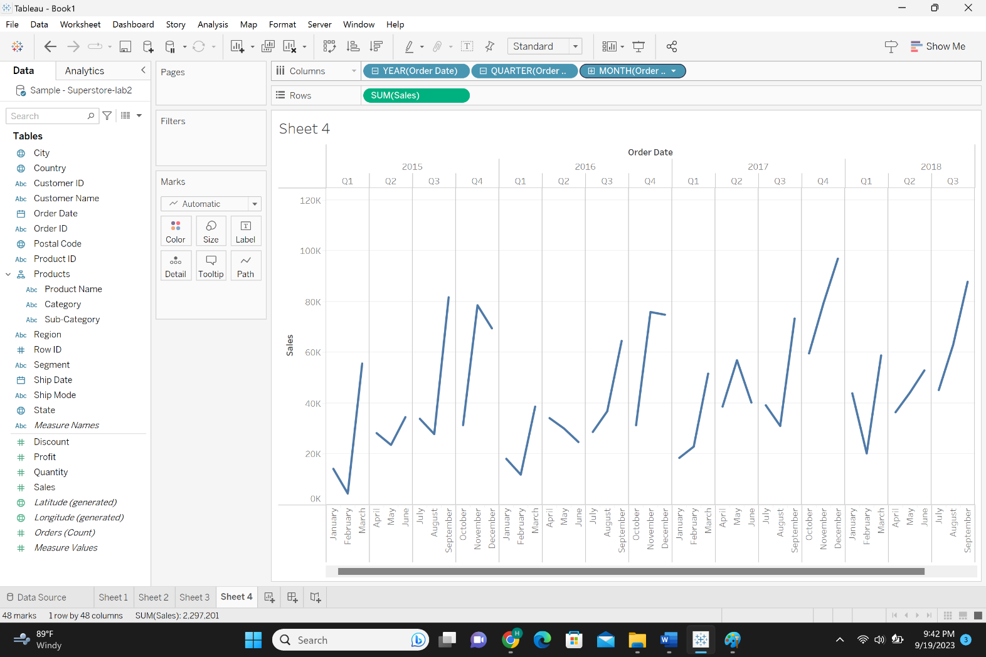

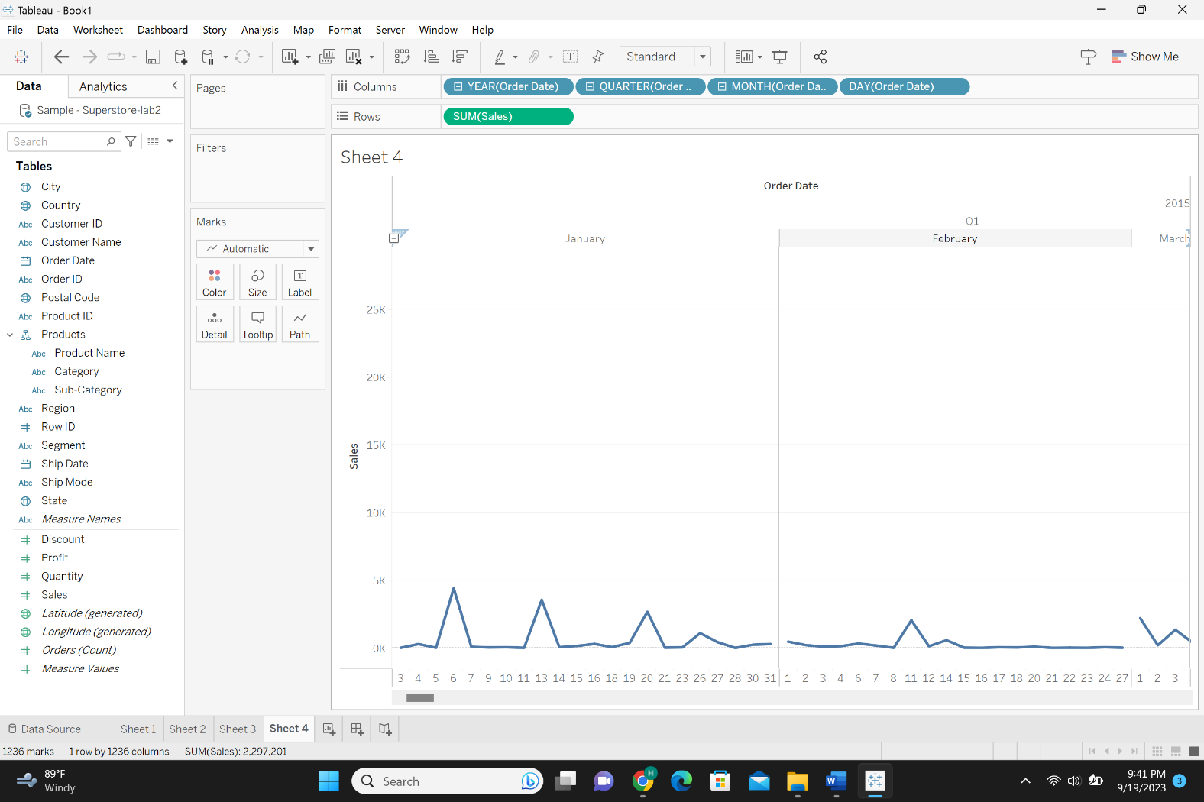
Q8: Sort the any column from “ABC” dataset take a snapshot of sheet5.
I sorted the Order Date in ascending order in the source file then viewed that in sheet 5.



